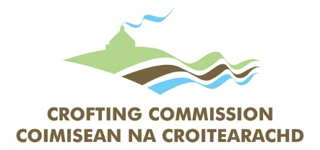

Complaints Form
You may use this form to make a formal complaint to the Crofting Commission. Please complete the sections below as accurately as possible.
1. Your Personal Details
If you would like to remain anonymous, please check the box below. If selected, no record of your name will be attached to the complaint.
- ☐ I wish to remain anonymous
Title:
Forename(s):
Surname:
Postal Address:
Post Code:
Telephone:
Email Address:
Email Consent: | I agree to communication by e-mail: | ☐ Yes | ☐ No
2. Croft Details (if applicable)
Croft Name:
Croft Ref Number:
Main Location Code:
3. Categorisation of Complaint
My complaint concerns (please select all that apply):
☐ Policy & Procedure
☐ Service Delivery
☐ Personnel
☐ Commissioners

Nature of your Complaint (please select all that apply):
☐ Service not delivered on time
☐ Received poor quality service
☐ Wrong or misleading information
☐ Complaint about staff member
☐ Other (please specify below)
4. Statement of Complaint
Please set out the facts below in chronological order, including important details and dates where possible.

5. Privacy & Submission
Privacy Notice: The Crofting Commission takes the protection of your privacy seriously. We only collect data necessary to carry out our regulatory functions. You can find our full Privacy Notice at: Privacy Notice | The Crofting Commission.
Signature: |  | Date:
How to Submit:
By Post: ‘Complaints’, Crofting Commission, Great Glen House, Leachkin Road, Inverness IV3 8NW
By Email: Save this document and e-mail as an attachment to complaints@crofting.gov.scot with ‘Complaint’ in the subject heading.

