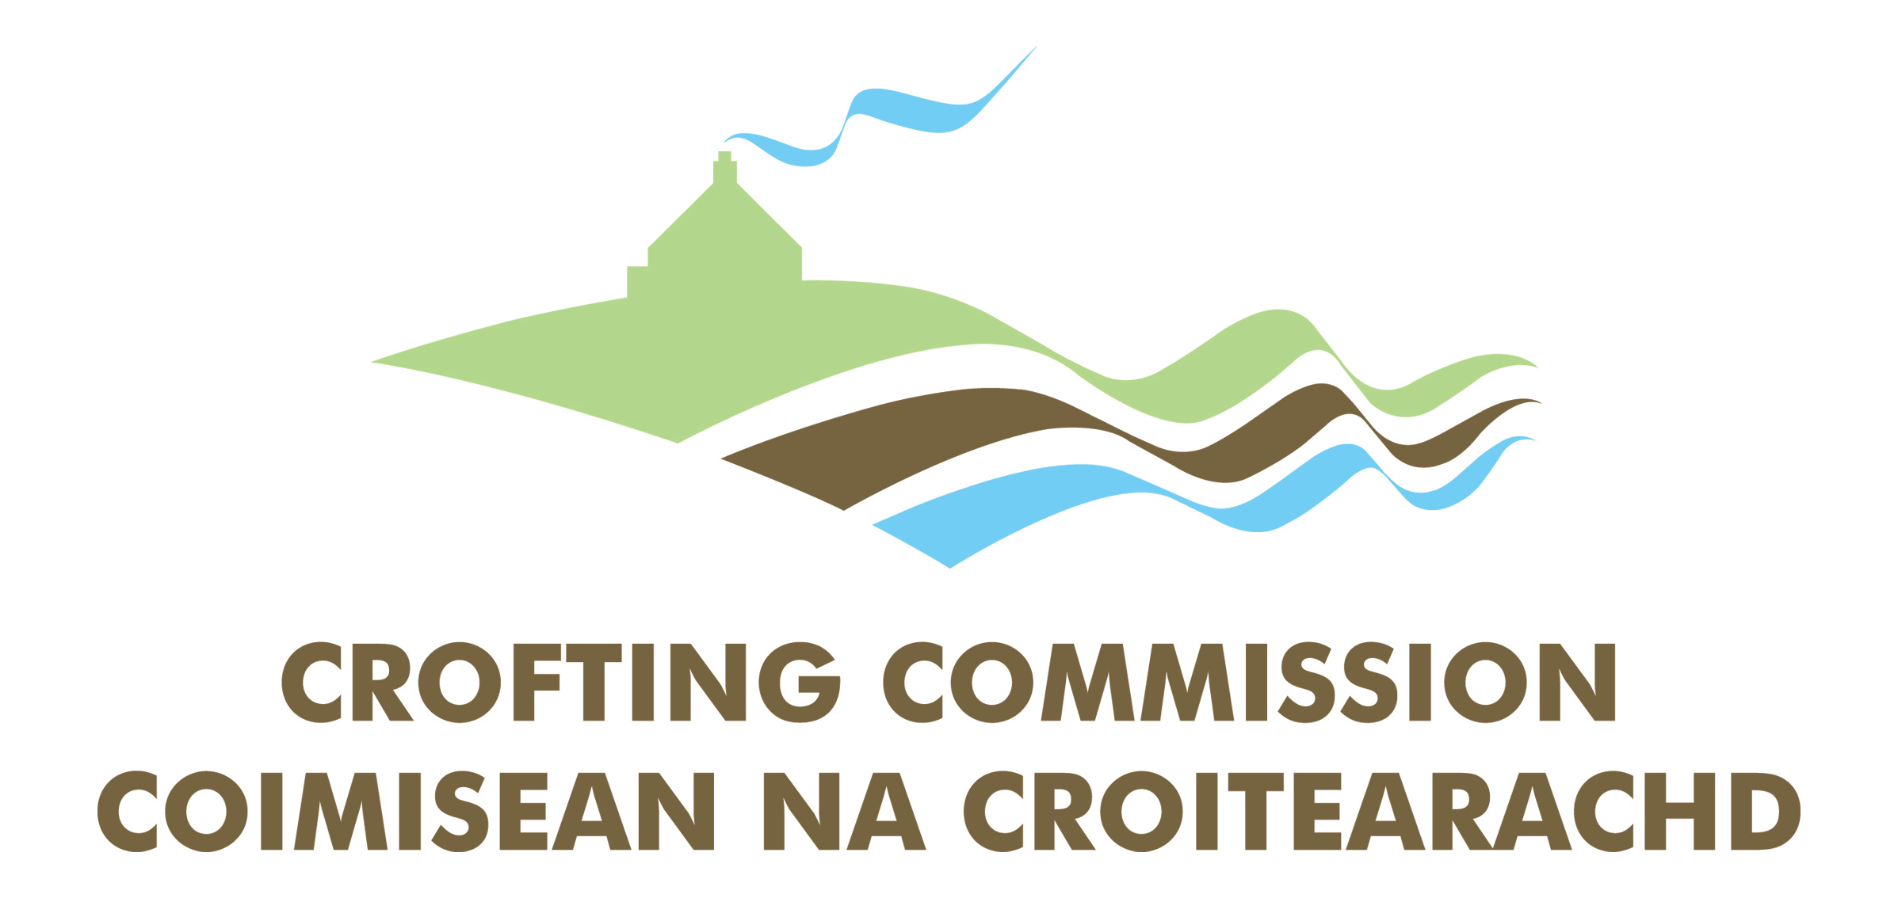

STANDARD OF SERVICE SURVEY

To help us monitor and improve our level of service, we welcome your comments and suggestions. Once completed, please return your form to Head of Corporate & Customer Services, Crofting Commission, Great Glen House, Leachkin Road, Inverness IV3 8NW or e-mail for the attention of Jane Thomas to info@crofting.scotland.gov.uk.

Your Reference Number (if known):

Overall, how satisfied are you with the quality of service you received? | Very satisfied  Somewhat satisfied  Neither satisfied nor dissatisfied  Somewhat dissatisfied  Very dissatisfied

How courteous have we been when dealing with your questions and concerns? | Extremely courteous  Very courteous  Somewhat courteous  Not so courteous  Not at all courteous

Did you receive a prompt and efficient service? | Yes No

Do you have any other comments/suggestions on the Standard of Service you received? What could we do better?

Please complete your contact details below:
Name:
Address:
 | Post Code:
E-mail:
Telephone No | Home:
 | Work:

